Supplementary Figures

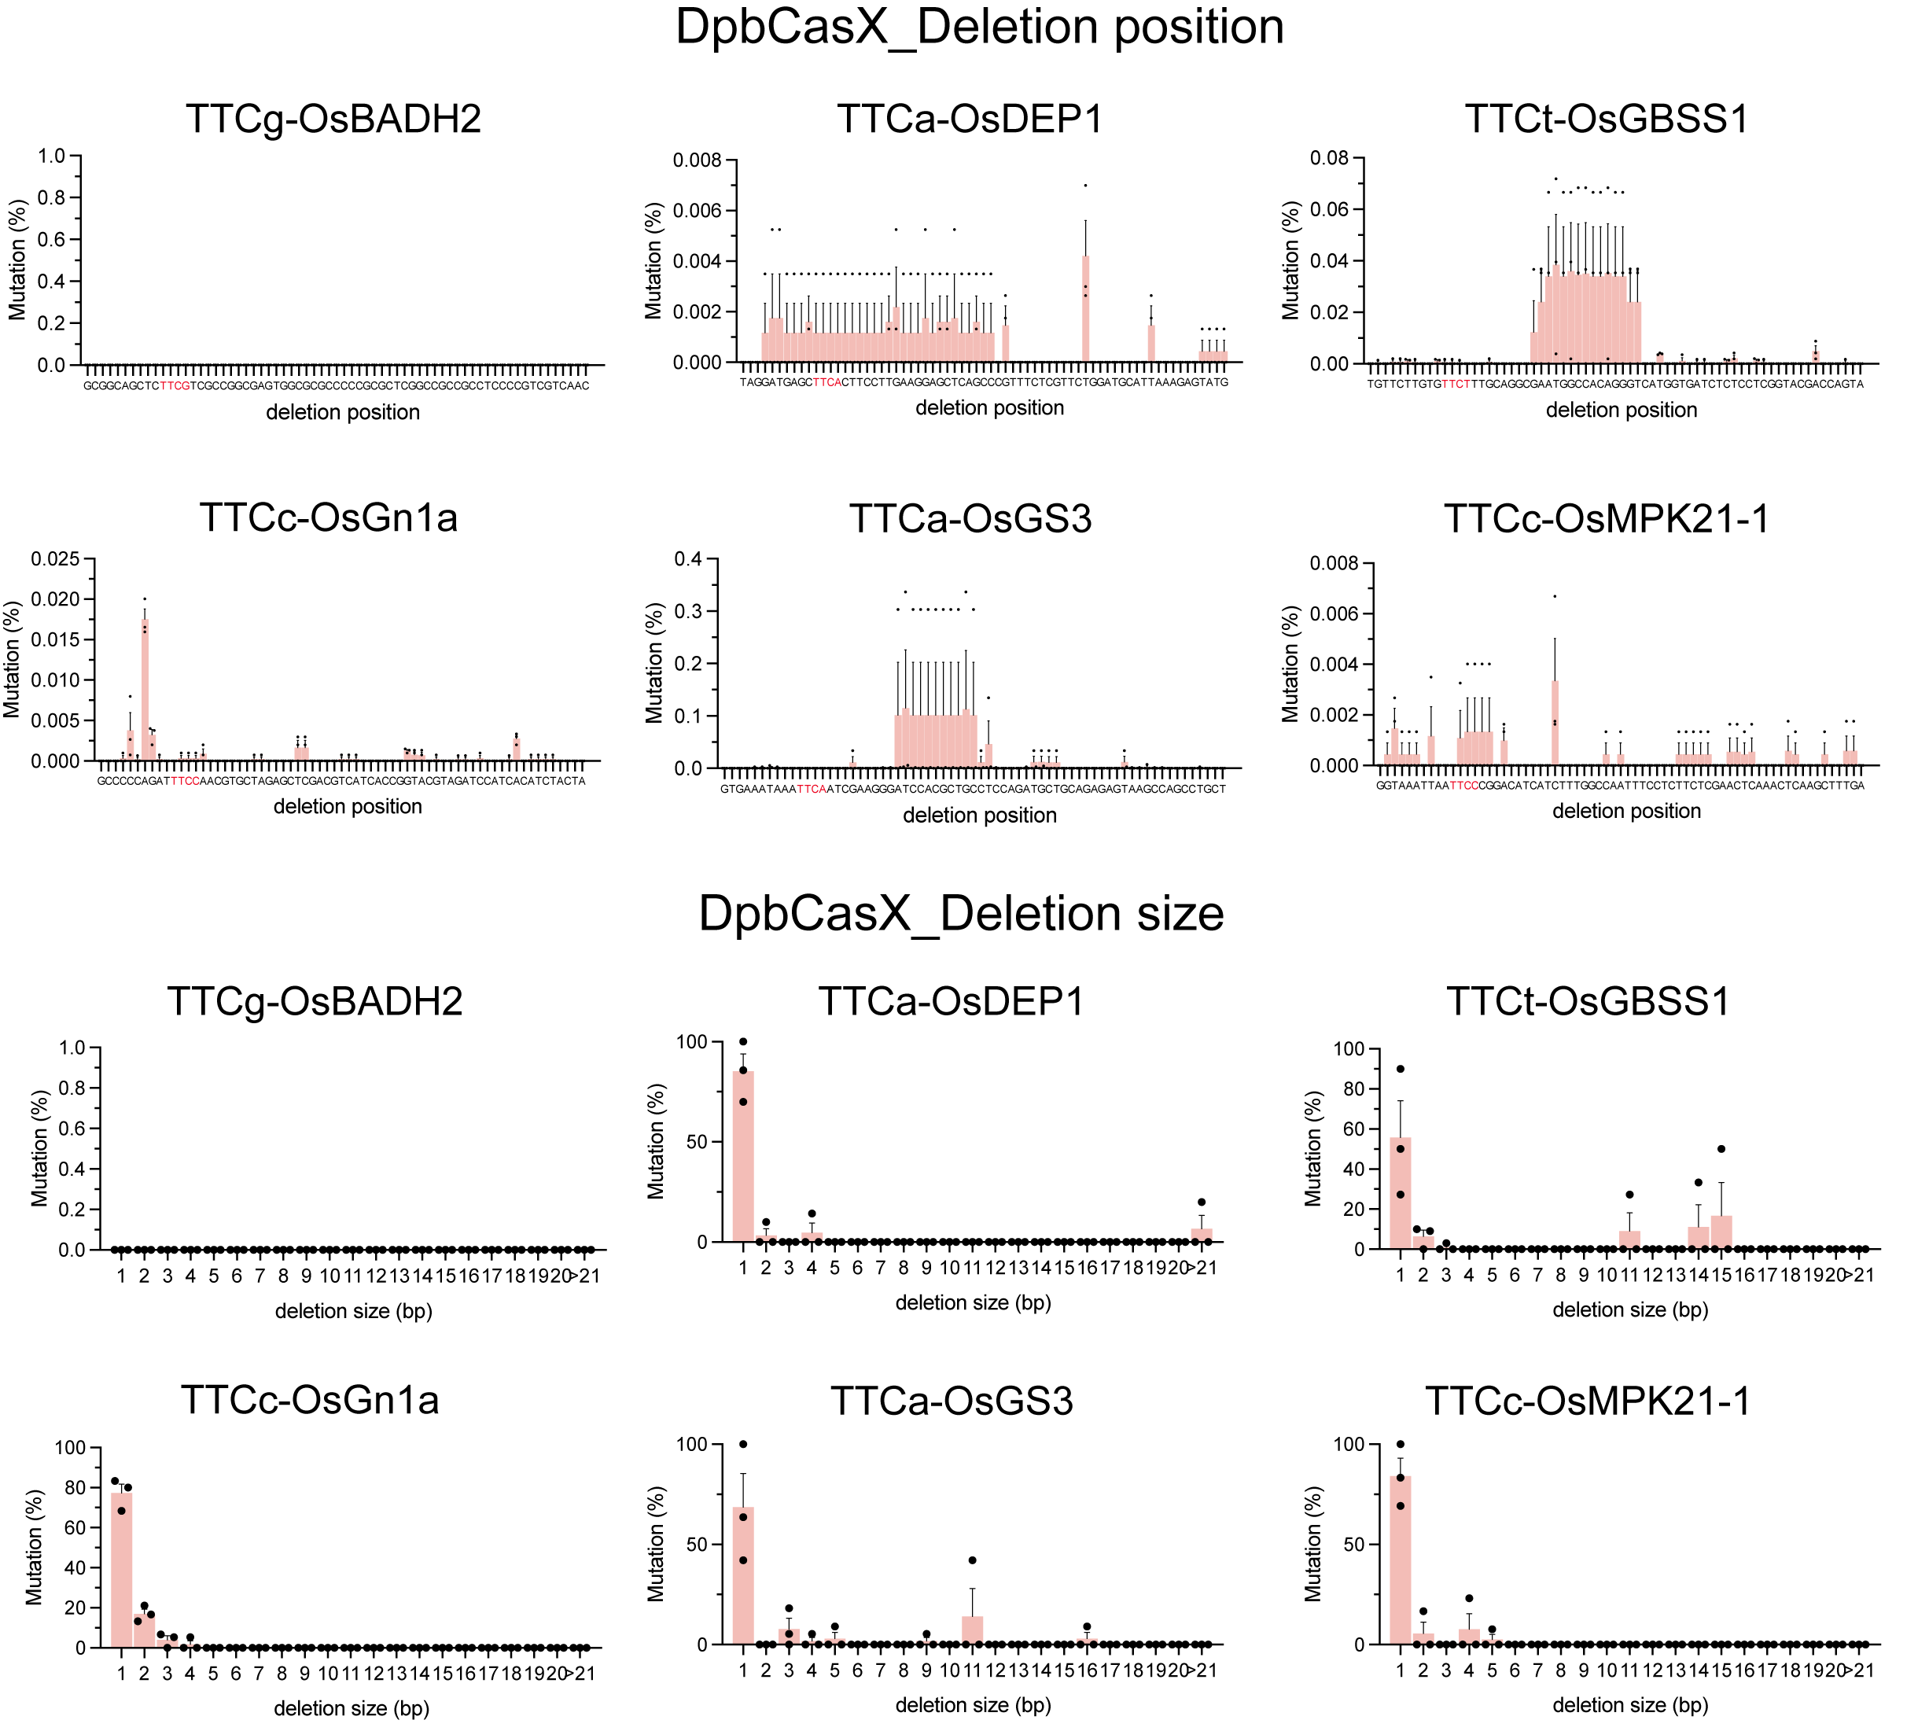
Supplementary Figure 1. Analysis of editing characteristics of DpbCasX variant.

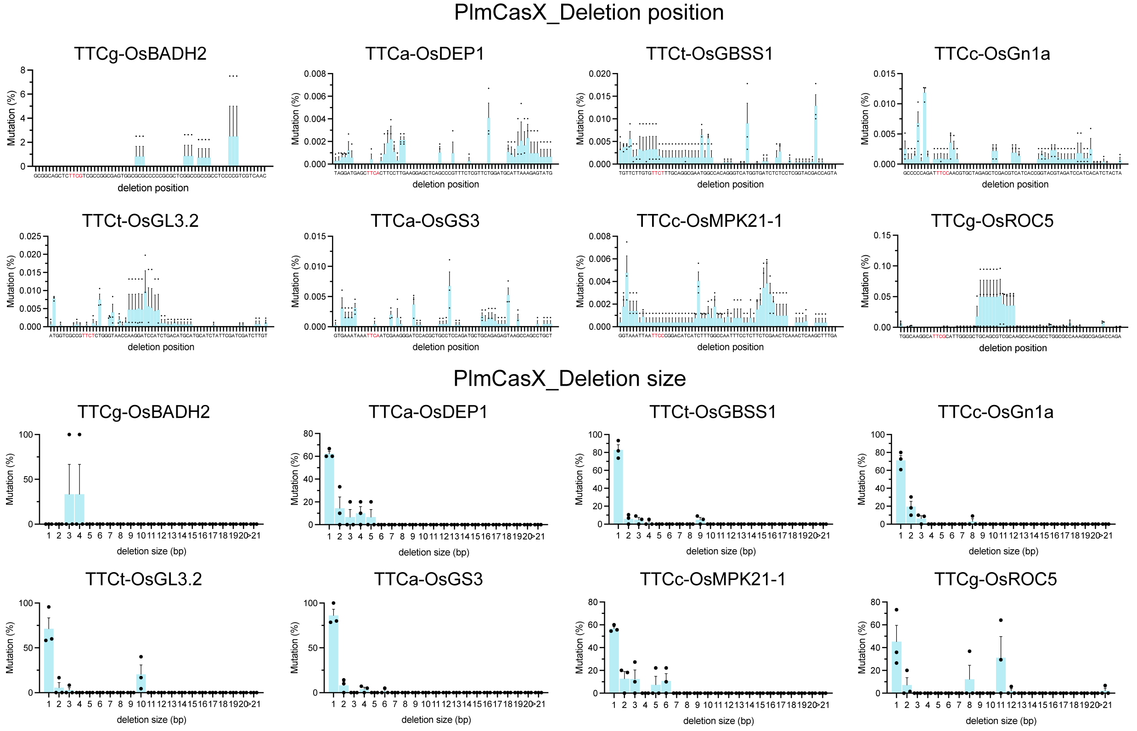
Supplementary Figure 2. Analysis of editing characteristics of PlmCasX variant.

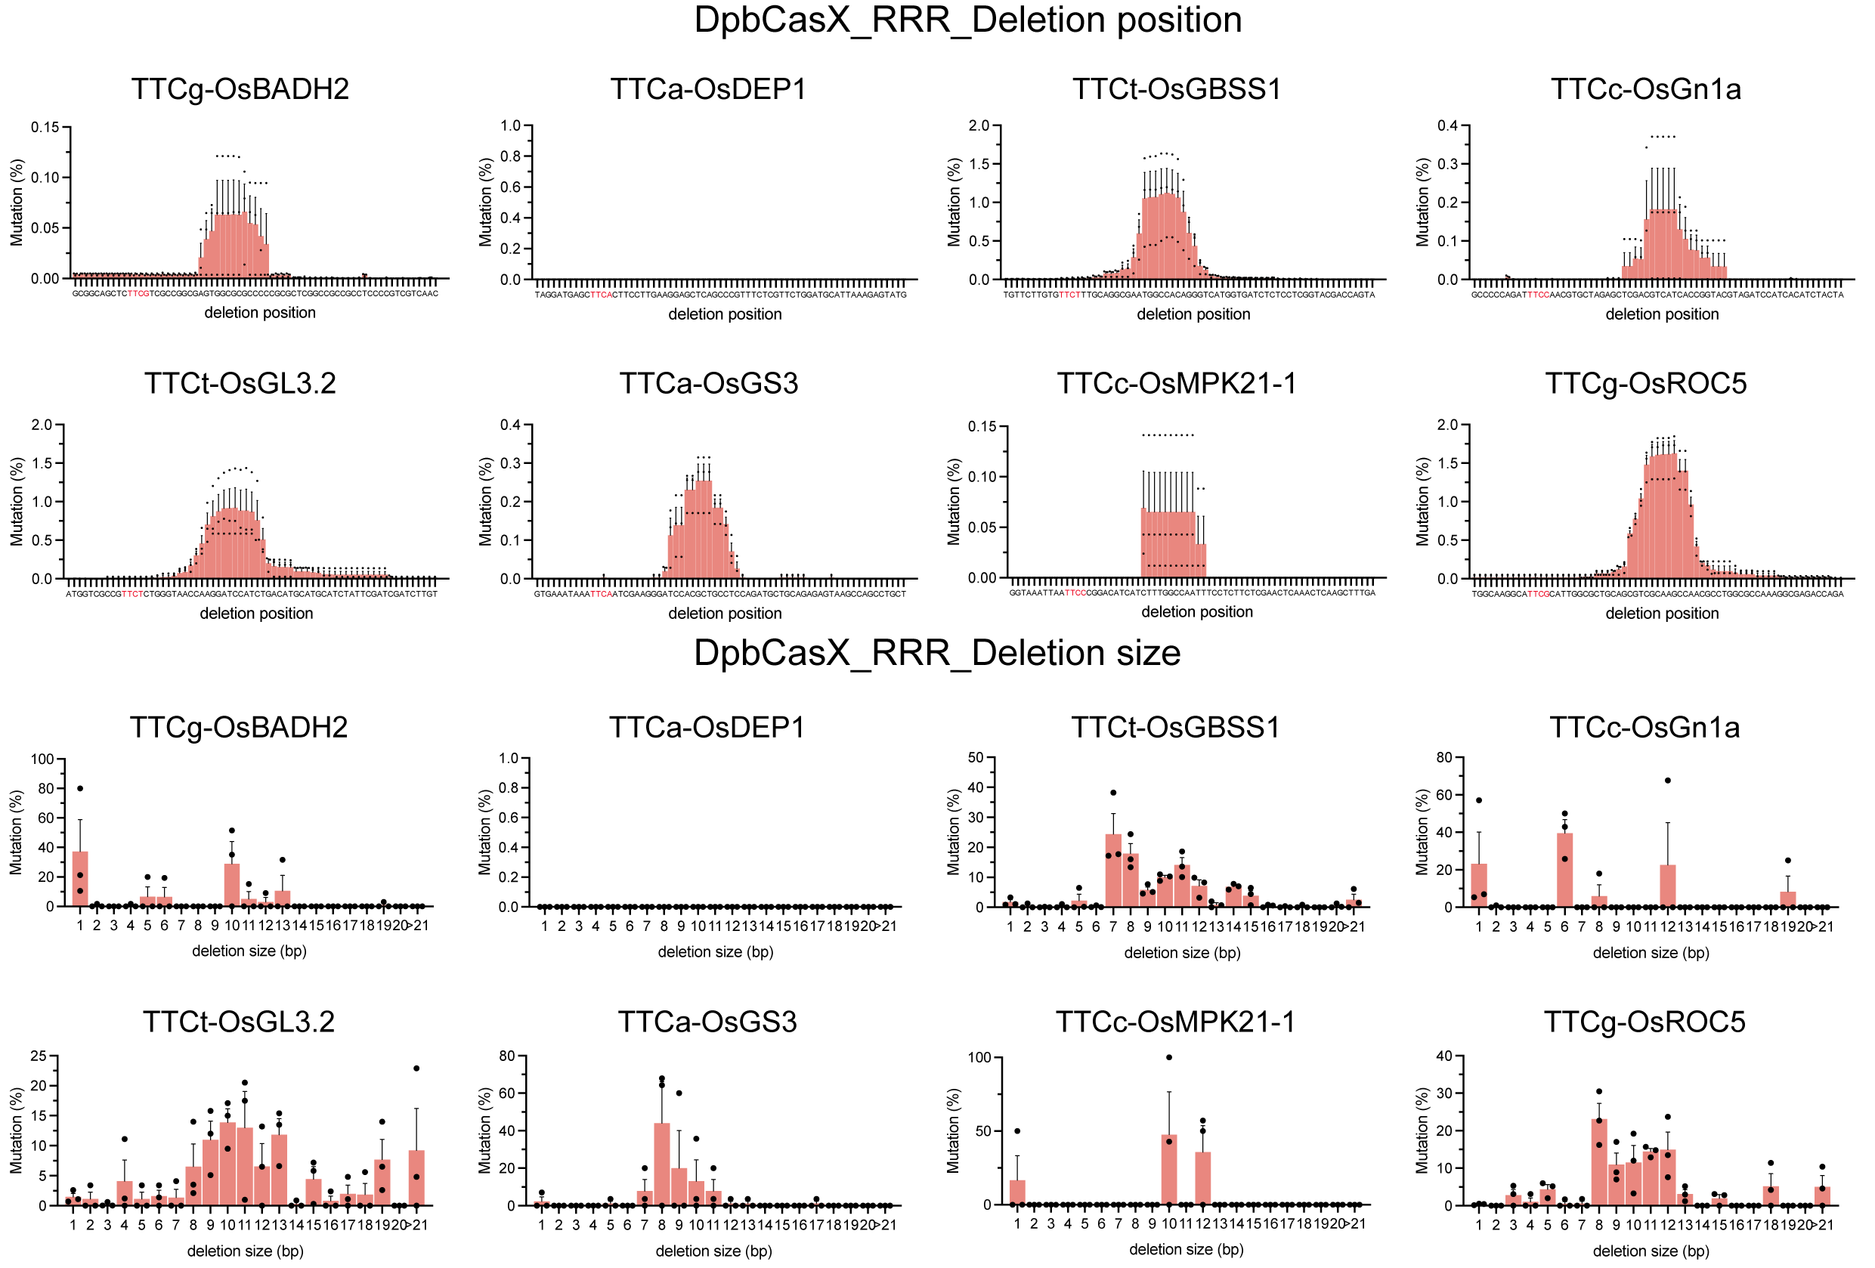
Supplementary Figure 3. Analysis of editing characteristics of DpbCasX_RRR variant.

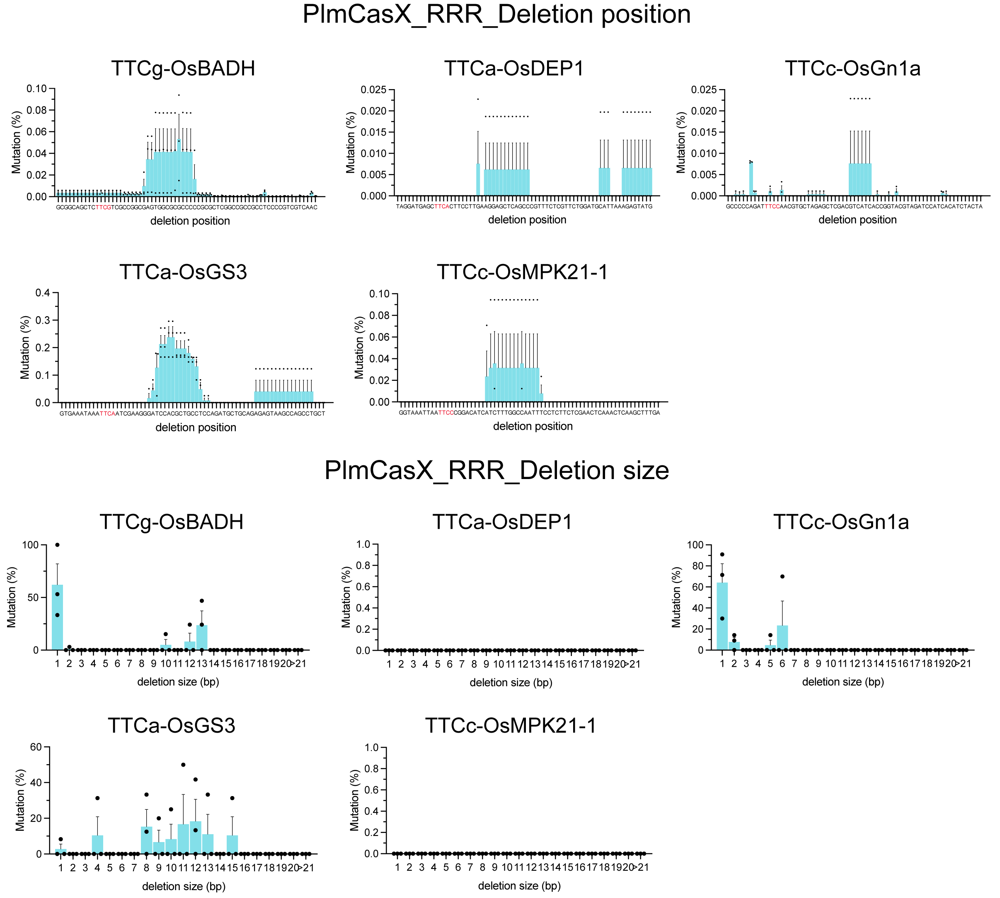
Supplementary Figure 4. Analysis of editing characteristics of PlmCasX_RRR variant.

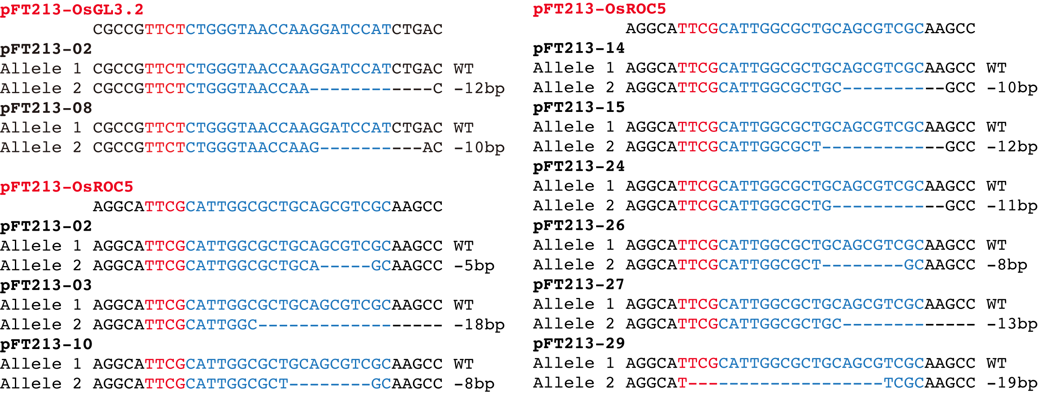
Supplementary Figure 5. The genotype of mutant plants induced by the PlmCasX_RRR variant.

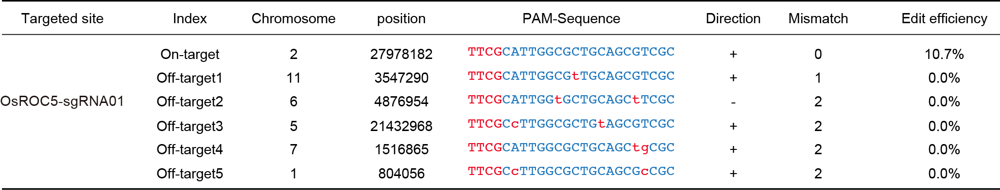
Supplementary Figure 6. Mutation analysis of sgRNA dependent off-target mutations in edited plants based on PlmCasX_RRR variant.

Supplementary Tables

Supplementary Table 1. T-DNA constructs used in this study.
Construct | Purpose
pTX1922 | For DpbCasX editing assay without sgRNA in rice
pTX1923 | For PlmCasX editing assay without sgRNA in rice
pFT140 | For DpbCasX editing assay on array 01 in rice
pFT141 | For DpbCasX editing assay on array 02 in rice
pFT142 | For PlmCasX editing assay on array 01 in rice
pFT143 | For PlmCasX editing assay on array 02 in rice
pFT208 | For DpbCasX_RRR editing assay without sgRNA in rice
pFT209 | For PlmCasX_RRR editing assay without sgRNA in rice
pFT210 | For DpbCasX_RRR editing assay on array 01 in rice
pFT211 | For DpbCasX_RRR editing assay on array 02 in rice
pFT212 | For PlmCasX_RRR editing assay on array 01 in rice
pFT213 | For PlmCasX_RRR editing assay on array 02 in rice

Supplementary Table 2. Targets sites tested in this study.
Name | Target site | Protospacer sequence | PAM
OsBADH2-TTCN-sgRNA01 | OsBADH2 | TCGCCGGCGAGTGGCGCGCC | TTCG
OsDEP1-TTCN-sgRNA01 | OsDEP1 | CTTCCTTGAAGGAGCTCAGC | TTCA
OsGBSS1-TTCN-sgRNA01 | OsGBSS1 | TTGCAGGCGAATGGCCACAG | TTCT
OsGn1a-TTCN-sgRNA01 | OsGn1a | AACGTGCTAGAGCTCGACGT | TTCC
OsGL3.2-TTCN-sgRNA01 | OsGL3.2 | CTGGGTAACCAAGGATCCAT | TTCT
OsGS3-TTCN-sgRNA01 | OsGS3 | ATCGAAGGGATCCACGCTGC | TTCA
OsMPK21-1-TTCN-sgRNA01 | OsMPK21-1 | CGGACATCATCTTTGGCCAA | TTCC
OsROC5-TTCN-sgRNA01 | OsROC5 | CATTGGCGCTGCAGCGTCGC | TTCG
site 1 | OsPDS | AAACCCTTAGAGATATCTAT | TTCA
site 2 | OsDEP1 | TGTCTTTGCTACTGTTGCAA | TTCA
site 3 | OsEPFL9 | TCCTCTTCTGTTTCCTGCTC | TTCT
site 4 | OsDEP1 | AGAAAGAGAAGGAGGCACAG | TTCC
site 5 | OsROC5 | TCTTGCGGGAGTTGCTGGGC | TTCC
site 6 | OsmiR528 | CTTTTGCCTCTCTCTCCTGT | TTCA
site 7 | OsROC5 | CCGGTTTTGTAAGCAGCTGG | TTCT
site 8 | OsROC5 | GCTTCCTGCAATGCCGGTAG | TTCT
site 9 | OsPDS | TTAAGACAAGAGATTTCACT | TTCC
site 10 | OsDEP1 | TCAAGGTGAGCGCCCCGCGG | TTCC

Supplementary Table 3. Oligos used in this study.
Name | Sequence (5'-3') | Description
FT066-F1 | GGTCTCCAAAGtcgccggcgagtggcgcgccTTTTTTTGAGCTCGGATCATGAACCAAC | Construction primer for multiplexed array 01 expression vector
FT066-F2 | GGTCTCCcttccttgaaggagctcagcTTTTTTTGAGCTCGGATCATGAACCAAC | Construction primer for multiplexed array 01 expression vector
FT066-F3 | GGTCTCCttgcaggcgaatggccacagTTTTTTTGAGCTCGGATCATGAACCAAC | Construction primer for multiplexed array 01 expression vector
FT066-R1 | GGTCTCGGAAGCTTTGATGCTTCTTATTTATCGG | Construction primer for multiplexed array 01 expression vector
FT066-R2 | GGTCTCGGCAACTTTGATGCTTCTTATTTATCGG | Construction primer for multiplexed array 01 expression vector
FT066-R3 | GGTCTCGAAAAacgtcgagctctagcacgttCTTTGATGCTTCTTATTTATCGG | Construction primer for multiplexed array 01 expression vector
FT067-F1 | GGTCTCCAAAGCTGGGTAACCAAGGATCCATTTTTTTTGAGCTCGGATCATGAACCAAC | Construction primer for multiplexed array 02 expression vector
FT067-F2 | GGTCTCCatcgaagggatccacgctgcTTTTTTTGAGCTCGGATCATGAACCAAC | Construction primer for multiplexed array 02 expression vector
FT067-F3 | GGTCTCCcggacatcatctttggccaaTTTTTTTGAGCTCGGATCATGAACCAAC | Construction primer for multiplexed array 02 expression vector
FT067-R1 | GGTCTCGCGATCTTTGATGCTTCTTATTTATCGG | Construction primer for multiplexed array 02 expression vector
FT067-R2 | GGTCTCGTCCGCTTTGATGCTTCTTATTTATCGG | Construction primer for multiplexed array 02 expression vector
FT067-R3 | GGTCTCGAAAAgcgacgctgcagcgccaatgCTTTGATGCTTCTTATTTATCGG | Construction primer for multiplexed array 02 expression vector
FT068 | tcgccggcgagtggcgcgcc | Sequencing primer for multiplexed gene expression vector
FT069 | CTGGGTAACCAAGGATCCAT | Sequencing primer for multiplexed gene expression vector
FT141-A | GAGGAAGCGGAAGAGCGCCGGTCTCGAATGGCTCCGAAGAAGAAGAGGAAGGTTGGC | Construction primer for CasX variant vector
FT141-B | GGGTTTTCATCGGTCCcctCCTAGAAACGGGCTTGGTTGCGTTGTCGGCGGAGAGC | Construction primer for CasX variant vector
FT141-C | CGACAACGCAACCAAGCCCGTTTCTAGGaggGGACCGATGAAAACCCTGCTTGTG | Construction primer for CasX variant vector
FT141-D | CGATGACACGTCCATTGGCCAAcctGATGAGGCCTGTCTCTAATGAGAGAAGGTC | Construction primer for CasX variant vector
FT141-E | TTCTCTCATTAGAGACAGGCCTCATCaggTTGGCCAATGGACGTGTCATCGAAAAGACC | Construction primer for CasX variant vector
FT141-F | TAGTAAACCCACAATTCGAGCATGTcctAGAAGTGTACTGAGCCAGGGTCTTGG | Construction primer for CasX variant vector
FT141-G | CCCTGGCTCAGTACACTTCTaggACATGCTCGAATTGTGGGTTTACTATAACAACGGC | Construction primer for CasX variant vector
FT141-H | CTGACCCTAAGGCTTTTCATCAGGTCTCGAAGCTCACTTCTTCTTCTTCGCC | Construction primer for CasX variant vector
FT142-B | GGGTTTTCATGGGGCCcctTTTGCCCGCCTTTTTAGTATTTGAATCTTTGACCAGC | Construction primer for CasX variant vector
FT142-C | AGATTCAAATACTAAAAAGGCGGGCAAAaggGGCCCCATGAAAACCCTACTTGTG | Construction primer for CasX variant vector
FT142-D | CGATTACCCTTCCATTCGCTAAcctTAACGAGCCTGTCTCTAAAGAGAGCAAATCG | Construction primer for CasX variant vector
FT142-E | TGCTCTCTTTAGAGACAGGCTCGTTAaggTTAGCGAATGGAAGGGTAATCGAAAAGACC | Construction primer for CasX variant vector
FT142-F | GGTAAAACCACAATTGGAACAGGTcctGCTAGTGTACTGGGCGAGCGTTTTGGACAG | Construction primer for CasX variant vector
FT142-G | CCAAAACGCTCGCCCAGTACACTAGCaggACCTGTTCCAATTGTGGTTTTACCATAACG | Construction primer for CasX variant vector
FT143-F | GGTCTCGAAAGtcgccggcgagtggcgcgccTTTTTTTGAGCTCGGATCATGAACCAAC | Construction primer for multiplexed array 01 expression vector
FT143-R | ggtctcgaaaaacgtcgagctctagcacgttCTTTGATGC | Construction primer for multiplexed array 01 expression vector
FT144-F | GGTCTCGAAAGCTGGGTAACCAAGGATCCATTTTTTTTGAGCTCGGATCATGAACCAAC | Construction primer for multiplexed array 02 expression vector
FT144-R | GGTCTCGAAAAgcgacgctgcagcgccaatgCTTTGATG | Construction primer for multiplexed array 02 expression vector
FT145 | CGATCTCCTGCTCTACCTGG | Sequencing primer for CasX variant vector
FT146 | GCCAGTCTGTGAGCACGGCC | Sequencing primer for CasX variant vector
FT147 | GGAATTGTCCGCGGAGCTTG | Sequencing primer for CasX variant vector
FT148 | TGGCCGCAGTCGAGGCAGAC | Sequencing primer for CasX variant vector
FT149 | TGCAAGGTATCAGTTCGGCG | Sequencing primer for CasX variant vector
FT150 | GATTGTGCATCTTCGCTCCG | Sequencing primer for CasX variant vector
FT151 | GAGTTGAAGGTAGAAGGCCA | Sequencing primer for CasX variant vector
FT152 | TGACAAGGCCTCGCCCGATC | Sequencing primer for CasX variant vector
FT153 | tcgccggcgagtggcgcgcc | Sequencing primer for multiplexed gene expression vector
FT154 | gctgagctccttcaaggaag | Sequencing primer for multiplexed gene expression vector
FT155 | CTGGGTAACCAAGGATCCAT | Sequencing primer for multiplexed gene expression vector
FT156 | gcagcgtggatcccttcgat | Sequencing primer for multiplexed gene expression vector
FT157 | cttccttgaaggagctcagc | Sequencing primer for CasX variant vector
FT299-OsROC5-F | cattggcgctgcagcgtcgc | OsROC5 forward sequencing primer
FT378-F1 | GGTCTCCAAAGAAACCCTTAGAGATATCTATTTTTTTTGAGCTCGGATCATGAACCAAC | Amplification primer for sgRNA array 03 expression cassette for PlmCasX_RRR genome editing system
FT378-F2 | GGTCTCCTGTCTTTGCTACTGTTGCAATTTTTTTGAGCTCGGATCATGAACCAAC | Amplification primer for sgRNA array 03 expression cassette for PlmCasX_RRR genome editing system
FT378-F3 | GGTCTCCtcctcttctgtttcctgctcTTTTTTTGAGCTCGGATCATGAACCAAC | Amplification primer for sgRNA array 03 expression cassette for PlmCasX_RRR genome editing system
FT378-F4 | GGTCTCCAGAAAGAGAAGGAGGCACAGTTTTTTTGAGCTCGGATCATGAACCAAC | Amplification primer for sgRNA array 03 expression cassette for PlmCasX_RRR genome editing system
FT378-R1 | GGTCTCGGACACTTTGATGCTTCTTATTTATCGG | Amplification primer for sgRNA array 03 expression cassette for PlmCasX_RRR genome editing system
FT378-R2 | GGTCTCGAGGACTTTGATGCTTCTTATTTATCGG | Amplification primer for sgRNA array 03 expression cassette for PlmCasX_RRR genome editing system
FT378-R3 | GGTCTCGTTCTCTTTGATGCTTCTTATTTATCGG | Amplification primer for sgRNA array 03 expression cassette for PlmCasX_RRR genome editing system
FT378-R4 | GGTCTCGAAAAgcccagcaactcccgcaagaCTTTGATGCTTCTTATTTATCGG | Amplification primer for sgRNA array 03 expression cassette for PlmCasX_RRR genome editing system
FT379-F1 | GGTCTCCAAAGCTTTTGCCTCTCTCTCCTGTTTTTTTTGAGCTCGGATCATGAACCAAC | Amplification primer for sgRNA array 04 expression cassette for PlmCasX_RRR genome editing system
FT379-F2 | GGTCTCCccggttttgtaagcagctggTTTTTTTGAGCTCGGATCATGAACCAAC | Amplification primer for sgRNA array 04 expression cassette for PlmCasX_RRR genome editing system
FT379-F3 | GGTCTCCgcttcctgcaatgccggtagTTTTTTTGAGCTCGGATCATGAACCAAC | Amplification primer for sgRNA array 04 expression cassette for PlmCasX_RRR genome editing system
FT379-F4 | GGTCTCCTTAAGACAAGAGATTTCACTTTTTTTTGAGCTCGGATCATGAACCAAC | Amplification primer for sgRNA array 04 expression cassette for PlmCasX_RRR genome editing system
FT379-R1 | GGTCTCGCCGGCTTTGATGCTTCTTATTTATCGG | Amplification primer for sgRNA array 04 expression cassette for PlmCasX_RRR genome editing system
FT379-R2 | GGTCTCGAAGCCTTTGATGCTTCTTATTTATCGG | Amplification primer for sgRNA array 04 expression cassette for PlmCasX_RRR genome editing system
FT379-R3 | GGTCTCGTTAACTTTGATGCTTCTTATTTATCGG | Amplification primer for sgRNA array 04 expression cassette for PlmCasX_RRR genome editing system
FT379-R4 | GGTCTCGAAAACCGCGGGGCGCTCACCTTGACTTTGATGCTTCTTATTTATCGG | Amplification primer for sgRNA array 04 expression cassette for PlmCasX_RRR genome editing system
FT380-F | TGTCTTTGCTACTGTTGCAA | Sequencing primer for sgRNA array 03 expression cassette for PlmCasX_RRR genome editing system
FT380-R | gagcaggaaacagaagagga | Sequencing primer for sgRNA array 03 expression cassette for PlmCasX_RRR genome editing system
FT380-R2 | CTGTGCCTCCTTCTCTTTCT | Sequencing primer for sgRNA array 03 expression cassette for PlmCasX_RRR genome editing system
FT381-F | ccggttttgtaagcagctgg | Sequencing primer for sgRNA array 04 expression cassette for PlmCasX_RRR genome editing system
FT381-R | ctaccggcattgcaggaagc | Sequencing primer for sgRNA array 04 expression cassette for PlmCasX_RRR genome editing system
FT381-R2 | AGTGAAATCTCTTGTCTTAA | Sequencing primer for sgRNA array 04 expression cassette for PlmCasX_RRR genome editing system
FT388-PDS-F | tgagttggatgctggatggATGAAACTGGGCTTCATATCTTTTG | Forward oligo to amplify the OsPDS-TTCN-sgRNA02 target site
FT388-PDS-R | tggagtgagtacggtgtgcCTACCATGTGTGTTAATCCTCAGAC | Reverse oligo to amplify the OsPDS-TTCN-sgRNA02 target site
FT389-DEP1-F | tgagttggatgctggatggTGGCATAATAATCTGTACTACTGCC | Forward oligo to amplify the OsDEP1-TTCN-sgRNA03 target site
FT389-DEP1-R | tggagtgagtacggtgtgcGCACGCACTGCAGTTTGG | Reverse oligo to amplify the OsDEP1-TTCN-sgRNA03 target site
FT390-EPFL9-F | tgagttggatgctggatggggcacaccaccatcctcc | Forward oligo to amplify the OsEPFL9-TTCN-sgRNA01 target site
FT390-EPFL9-R | tggagtgagtacggtgtgctgcaggagaacagaagaaaagac | Reverse oligo to amplify the OsEPFL9-TTCN-sgRNA01 target site
FT391-DEP1-F | tgagttggatgctggatggCACTAATACCAACGTATGGCCTC | Forward oligo to amplify the OsDEP1-TTCN-sgRNA02 target site
FT391-DEP1-R | tggagtgagtacggtgtgcTGTTCTTGCCCCTCAGAACC | Reverse oligo to amplify the OsDEP1-TTCN-sgRNA02 target site
FT392-ROC5-F | tgagttggatgctggatgggatgacgagggacactgagg | Forward oligo to amplify the OsROC5-TTCN-sgRNA04 target site
FT392-ROC5-R | tggagtgagtacggtgtgcggatgcaaagtacgagcgag | Reverse oligo to amplify the OsROC5-TTCN-sgRNA04 target site
FT393-miR528-F | tgagttggatgctggatggGTTAGGTCTGGTTTTTTGGCTG | Forward oligo to amplify the OsmiR528-TTCN-sgRNA01 target site
FT393-miR528-R | tggagtgagtacggtgtgcAGTTTCTCCTACCGCTGCTG | Reverse oligo to amplify the OsmiR528-TTCN-sgRNA01 target site
FT394-ROC5-F | tgagttggatgctggatggttcttgtgtttgcttgcaacag | Forward oligo to amplify the OsROC5-TTCN-sgRNA02 target site
FT394-ROC5-R | tggagtgagtacggtgtgccagccggaaggtaccctc | Reverse oligo to amplify the OsROC5-TTCN-sgRNA02 target site
FT395-ROC5-F | tgagttggatgctggatggatgtactaatgttggtgttacttgc | Forward oligo to amplify the OsROC5-TTCN-sgRNA03 target site
FT395-ROC5-R | tggagtgagtacggtgtgctatgttagctacgtcttacactatgtaag | Reverse oligo to amplify the OsROC5-TTCN-sgRNA03 target site
FT396-PDS-F | tgagttggatgctggatggCAAGCAAGATCTTTTGCGGG | Forward oligo to amplify the OsPDS-TTCN-sgRNA01 target site
FT396-PDS-R | tggagtgagtacggtgtgcTTTTCACAAGAGATGGAATGTGAGG | Reverse oligo to amplify the OsPDS-TTCN-sgRNA01 target site
FT397-DEP1-F | tgagttggatgctggatggCGCCGAGGCCCAAGTC | Forward oligo to amplify the OsDEP1-TTCN-sgRNA04 target site
FT397-DEP1-R | tggagtgagtacggtgtgcAAAGTCAAAGGAAGACGAAGCAAG | Reverse oligo to amplify the OsDEP1-TTCN-sgRNA04 target site

